
UNIVERSITY OF TURKISH AERONAUTICAL ASSOCIATION

ENGINEERING FACULTY
DEPARTMENT OF COMPUTER ENGINEERING

CENG 495 Senior Design Project I
Project Title: NeuroPathDriver

Mehmet Efe KAPISIZ - 210444029

Ziya KARAKAYA

09.01.2025
Table of Content
1
1. Introduction 1
1.1. Purpose of the System 1
1.2. Scope of the System 1
1.3. Objectives and Success Criteria of the Project 1
1.4. Definitions, Acronyms, and Abbreviations 1
1.5. References 1
1.6. Overview 2
2. Current System 2
3. Proposed System 2
3.1. Overview 2
3.2. Functional Requirements 2
3.3. Nonfunctional Requirements 3
3.3.1. Usability 3
3.3.2. Reliability 3
3.3.3. Performance 3
3.3.4. Supportability 3
3.3.5. Implementation 3
3.3.6. Interface 3
3.3.7. Packaging 4
3.3.8. Legal 4
3.4. System Models 4
3.4.1. Scenarios 4
3.4.2. Use Case Model 4
3.4.3. Analysis Object Model 5
3.4.4. Dynamic Model 5

1. Introduction

1.1. Purpose of the System
The goal of this project is to design and implement a self-driving vehicle using Reinforcement Learning (RL). The system focuses on an artificial intelligence model capable of adapting to environmental conditions and making autonomous decisions while adhering to traffic rules. This study aims to support the development of autonomous driving technologies and contribute to innovations in this field.

1.2. Scope of the System
Simulation Environment: The system has been developed to run on a simulation platform.
Reinforcement Learning Algorithm: The project will use modern Reinforcement Learning algorithms such as Q-learning, Deep Q-Networks (DQN) or Proximal Policy Optimization (PPO) to manage the vehicle's dynamic decision-making processes.
Decision Making and Learning Processes: The system will be optimized to both avoid collisions and reach the target in the shortest time.
Sensor System: The vehicle will require sensors to perceive its environment.

1.3. Objectives and Success Criteria of the Project
Goals:
- To create a continuously learning and self-improving system using RL algorithms.
- To achieve safe and efficient autonomous driving.
Success Criteria:
- To successfully perform autonomous driving in a simulation environment, adhering to traffic regulations.

1.4. Definitions, Acronyms, and Abbreviations
- RL: Reinforcement Learning
- AI: Artificial Intelligence
- DNN: Deep Neural Network
- DQN: Deep Q-Network
- PPO: Proximal Policy Optimization

1.5. References
- Arulkumaran, K., Deisenroth, M. P., Brundage, M., & Bharath, A. A. (2017). A brief survey of deep reinforcement learning. arXiv preprint arXiv:1708.05866.
- Juliani, A. (2018). Unity: A general platform for intelligent agents. arXiv preprint arXiv:1809.02627.
- Kaelbling, L. P., Littman, M. L., & Moore, A. W. (1996). Reinforcement learning: A survey. Journal of artificial intelligence research, 4, 237-285.
- Klokova, M. (2023, September 18). Unity ML-Agents: Bridging the gap between game developers and machine learning enthusiasts. Medium. https://medium.com/@marizombie/unity-ml-agents-bridging-the-gap-between-game-developers-and-machine-learning-enthusiasts-9e2ffbf17dc
- Simonini, T. (2020, January 30). An introduction to Unity ML-Agents. Towards Data Science. https://medium.com/towards-data-science/an-introduction-to-unity-ml-agents-6238452fcf4c
- Simonini, T. (2020, February 3). Diving deeper into Unity-ML Agents. Towards Data Science. https://towardsdatascience.com/diving-deeper-into-unity-ml-agents-e1667f869dc3

1.6. Overview
This project focuses on developing a self-driving car simulation using Reinforcement Learning (RL) in a controlled virtual environment. The system utilizes RL algorithms, where an agent (the self-driving car) interacts with the environment, receives feedback (rewards or penalties), and improves its driving strategy over time. This approach aims to replicate the decision-making process of human drivers by continuously learning from past actions and experiences.
The primary goal of this project is to design and implement a system capable of effectively training a self-driving car to drive autonomously in a simulated environment.

2. Current System
Current systems often rely on predetermined solutions such as rule-based algorithms or roadmaps. These approaches may fall short in unpredictable scenarios and have limited flexibility in decision-making. On the other hand, RL-based approaches can successfully tackle complex decision-making problems throughout the learning process.

3. Proposed System

3.1. Overview
The proposed system is designed as an autonomous driving system that learns and makes decisions by interacting with the environment using RL algorithms. The system learns optimal driving behaviors by perceiving its environment.

3.2. Functional Requirements
- The vehicle should be able to process data from environmental sensors to move safely and smoothly. It should avoid collisions and obey traffic rules.
- The vehicle should be able to perceive its environment using Reinforcement Learning algorithms and incorporate this information into the decision-making process.

- The vehicle should be able to learn continuously in a simulated environment through a reward-penalty mechanism.
- It should be able to dynamically learn and apply basic vehicle control functions such as braking, acceleration, and turning.
- The vehicle should operate within defined speed limits.

3.3. Nonfunctional Requirements

3.3.1. Usability
The system should provide a user-friendly interface and simple design, allowing simulation users and test operators to easily manage the project. A trained user should be able to operate the system and use the vehicle control functions integrated into the simulation with minimal learning time. User feedback mechanisms should also be integrated into the software.

3.3.2. Reliability
The system must maintain uninterrupted and error-free functionality, even during long-term operations. The failure rate should be minimal for critical security scenarios. Additionally, the accuracy of data from sensors should be continuously monitored, and the effects of erroneous data should be minimized.

3.3.3. Performance
The simulation should run in real-time with minimal latency. Vehicle control decisions, data processing, and environmental simulation must be executed rapidly. The simulation should be able to handle large datasets quickly using performance-optimized algorithms.

3.3.4. Supportability
The system should be easily maintainable, updatable, and capable of troubleshooting. And system should be easily expandable according to future needs.

3.3.5. Implementation
The system should be easy to install and configure. Components such as tools, sensors, and environmental simulations should be designed with a modular structure and be able to be updated individually when necessary. The software should be able to run on different operating systems and be quickly adaptable to user needs.

3.3.6. Interface
The simulation should provide an interface where users can visualize vehicle control algorithms, environmental sensors, and traffic conditions. Additionally, it should support integration by offering open APIs for external systems and sensors.

3.3.7. Packaging
Simulation software should be maintained in a format that is easily accessible to end-users. Additionally, it should integrate with standard version control tools like 'Git' and be guaranteed to be adaptable to different systems.

3.3.8. Legal
The system must comply with all relevant legal regulations and ethical standards. Privacy and data security must be prioritized.

3.4. System Models

3.4.1. Scenarios
Destination Navigation: The driver specifies the desired destination. The vehicle calculates the optimal route and drives autonomously to the destination, adhering to traffic rules, avoiding obstacles, and ensuring passenger safety.
Obstacle Avoidance: When the vehicle encounters an obstacle in front of it or on the road, it reduces speed, stops, or maneuvers safely around the obstacle.
Lane Changing: The vehicle changes lanes to reduce traffic congestion, move to a faster lane, or in situations such as lane endings.

3.4.2. Use Case Model
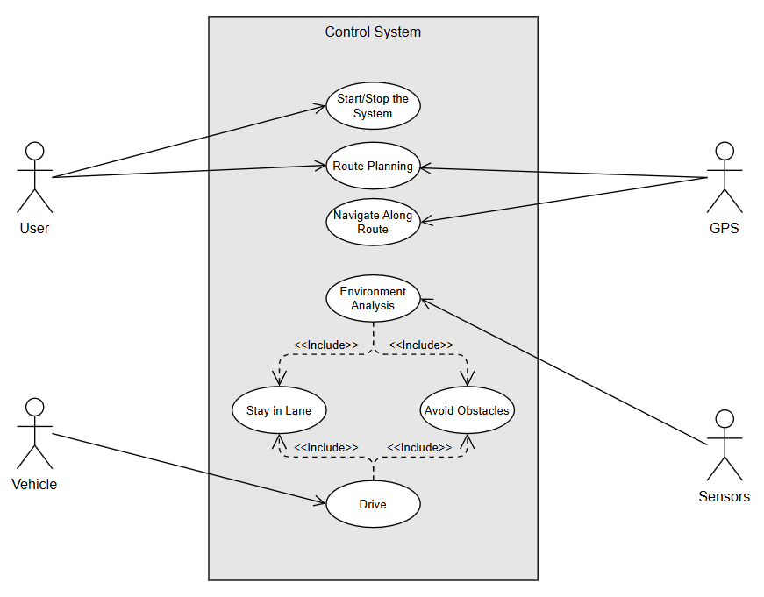

3.4.3. Analysis Object Model

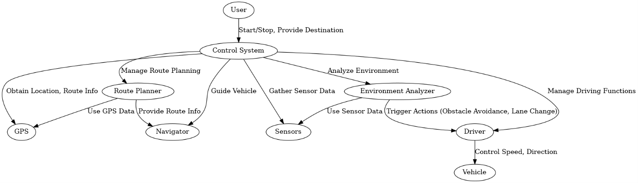
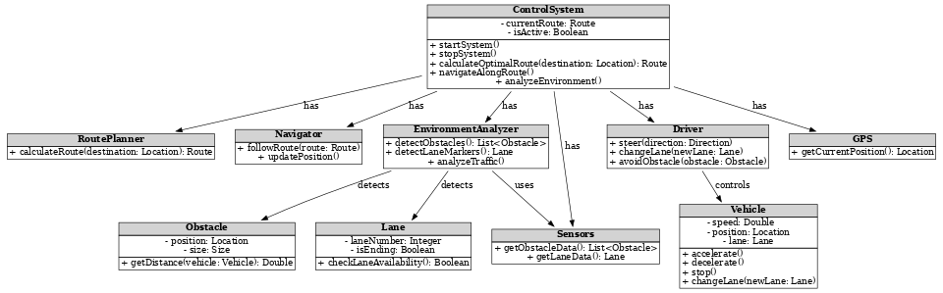

3.4.4. Dynamic Model
